# Project: Summarizing and Analyzing Research Papers

**Learner Name**: devesh tiwari

**Learner Email**: [deveshtiwari25082005@gmail.com](mailto:deveshtiwari25082005@gmail.com)

* **Topic**: education (MEDCO: Medical Education Copilots Based on A Multi-Agent Framework)
* **Research Paper**: <https://arxiv.org/pdf/2408.12496>

**Initial prompt:**

* 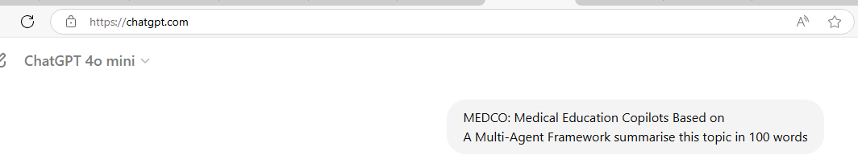

**Description:**

The initial prompt generates a general summary of the research paper within 100 words.

**Generated summary:**

MEDCO, or Medical Education Copilots, leverages a multi-agent framework to enhance medical training and education. This system integrates multiple intelligent agents to support learners through personalized, adaptive guidance and feedback. By simulating real-world medical scenarios and providing dynamic, context-sensitive assistance, MEDCO aims to improve the effectiveness and efficiency of medical education. The framework allows for a tailored learning experience, addressing individual needs and learning styles, and facilitating a more interactive and immersive training environment. Overall, MEDCO represents a significant advancement in utilizing AI-driven tools to support and optimize medical education.

**Iteration 1:**

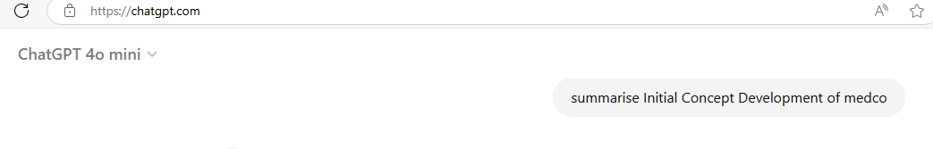

**Description:**

The Initial Concept Development of MEDCO involves laying the groundwork for a multi-agent framework designed to enhance medical education. This phase is crucial for defining the system's fundamental structure and purpose.

**Generated summary:**

The Initial Concept Development of MEDCO involves defining the foundational idea of using a multi-agent framework to enhance medical education. This phase focuses on conceptualizing how multiple intelligent agents will function together to support learners. Key aspects include outlining the specific roles each agent will play, such as delivering content, providing feedback, and simulating medical scenarios. The goal is to create a cohesive system where these agents interact seamlessly to offer personalized and adaptive learning experiences. This stage sets the groundwork for the system’s design and development, ensuring it aligns with educational objectives and learner needs.

**Iteration 2:**



**Description:**

Ongoing Maintenance and Updates for MEDCO focus on ensuring the system remains effective, current, and responsive to the evolving needs of medical education.

**Generated summary:**

Ongoing Maintenance and Updates for MEDCO involve continuously refining and enhancing the system to ensure it remains effective and relevant. This phase includes regularly updating the multi-agent framework to incorporate new advancements in medical education, address user feedback, and integrate technological improvements. The focus is on fixing any issues, improving system performance, and adapting to evolving educational needs. By maintaining and updating MEDCO, the system stays current with best practices, ensuring sustained effectiveness in supporting medical learners and optimizing their educational experience.

**Final prompt:**

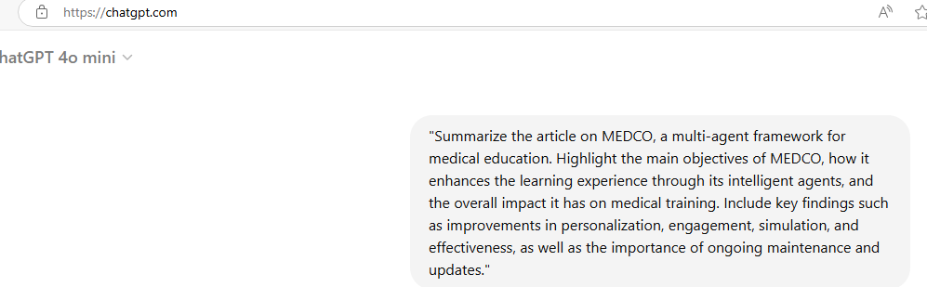

**Description:**

The article on MEDCO, a multi-agent framework for medical education, details how this system aims to revolutionize medical training by integrating multiple intelligent agents into the educational process.

**Generated summary:**

The article on MEDCO, a multi-agent framework for medical education, explores how this innovative system enhances training through a network of intelligent agents. MEDCO’s primary objectives include providing personalized learning experiences, improving learner engagement, and simulating real-world medical scenarios.

**Key Findings:**

1. **Personalization**: MEDCO’s agents tailor educational content and feedback to individual learners' needs, promoting a customized learning journey.

2. **Engagement**: Interactive agents increase learner engagement by offering dynamic, context-sensitive support.

3. **Simulation**: The framework’s ability to recreate realistic medical scenarios enhances practical training and preparedness.

4. **Effectiveness**: Early evaluations indicate that MEDCO significantly improves learning outcomes compared to traditional methods.

5. **Maintenance and Updates**: Continuous updates and maintenance are crucial for integrating new content, addressing user feedback, and keeping the system technologically current.

Overall, MEDCO represents a significant advancement in medical education, leveraging AI to create a more effective and responsive learning environment.

**Potential Applications of MEDCO:**

**Clinical Training**: MEDCO can be used to simulate complex clinical scenarios, allowing medical students and professionals to practice and refine their diagnostic and treatment skills in a risk-free environment.

**Continuing Medical Education (CME)**: The system can facilitate ongoing learning for healthcare professionals by providing updated medical content, case studies, and interactive simulations relevant to their practice areas.

**Medical Simulation Labs**: Integrating MEDCO into simulation labs can enhance the realism and interactivity of training exercises, offering learners a more immersive experience.

**Remote Learning**: MEDCO can support remote medical education by providing access to interactive modules and simulations online, enabling learners to engage in practical training from different locations.

**Assessment and Evaluation**: The framework can be used for assessing learner performance through simulations and adaptive feedback, helping educators evaluate competencies and identify areas for improvement.

**Interdisciplinary Training**: MEDCO can be employed in training scenarios that require collaboration among different medical specialties, enhancing teamwork and communication skills through integrated simulations.

**Emergency Preparedness**: The system can simulate emergency situations, allowing learners to practice and prepare for high-pressure scenarios and develop quick decision-making skills.

**Patient Education**: MEDCO’s simulations and interactive tools can be adapted for patient education, helping patients understand medical conditions and treatments through engaging and personalized content.

These applications demonstrate MEDCO’s versatility and potential to significantly impact various aspects of medical education and training.

**Overall Evaluation Summary:**

MEDCO demonstrates significant potential to enhance medical education through improved learner outcomes, increased engagement, and practical application of skills. However, successful implementation requires careful consideration of technical and logistical aspects, with ongoing maintenance and updates essential to maintaining system efficacy and relevance.

窗体顶端

窗体底端

***Overall Relevance:**

MEDCO is highly relevant in the context of modern medical education. It addresses key challenges such as personalization, practical simulation, and technological integration, while also providing flexibility and ongoing support for learners and professionals. Its ability to adapt to changing educational needs and technological advancements ensures that it remains a valuable tool for enhancing medical training and practice.

**Overall Reflection:**

MEDCO embodies a forward-thinking approach to medical education, leveraging technology to create more personalized and effective learning experiences. Its successful implementation could redefine how medical training is conducted, offering a model for integrating advanced tools into educational practices. However, ongoing attention to its practical challenges and continuous adaptation will be key to realizing its full potential and ensuring its sustained impact on medical education and professional development.